|  |  |
| --- | --- |
| Our Baby sailboat_bkgrnd_border_2 | |
|  | |
| nautical_stripe_border | |
| Born: at in | |
| Weight: | Length: |

|  |  |
| --- | --- |
| First Month | |
|  | |
| Date: | |
| Weight: | Length: |
| Notes: | |







|  |  |
| --- | --- |
| Second Month | |
|  | |
| Date: | |
| Weight: | Length: |
| Notes: | |







|  |  |
| --- | --- |
| Third Month | |
|  | |
| Date: | |
| Weight: | Length: |
| Notes: | |







|  |  |
| --- | --- |
| Fourth Month | |
|  | |
| Date: | |
| Weight: | Length: |
| Notes: | |



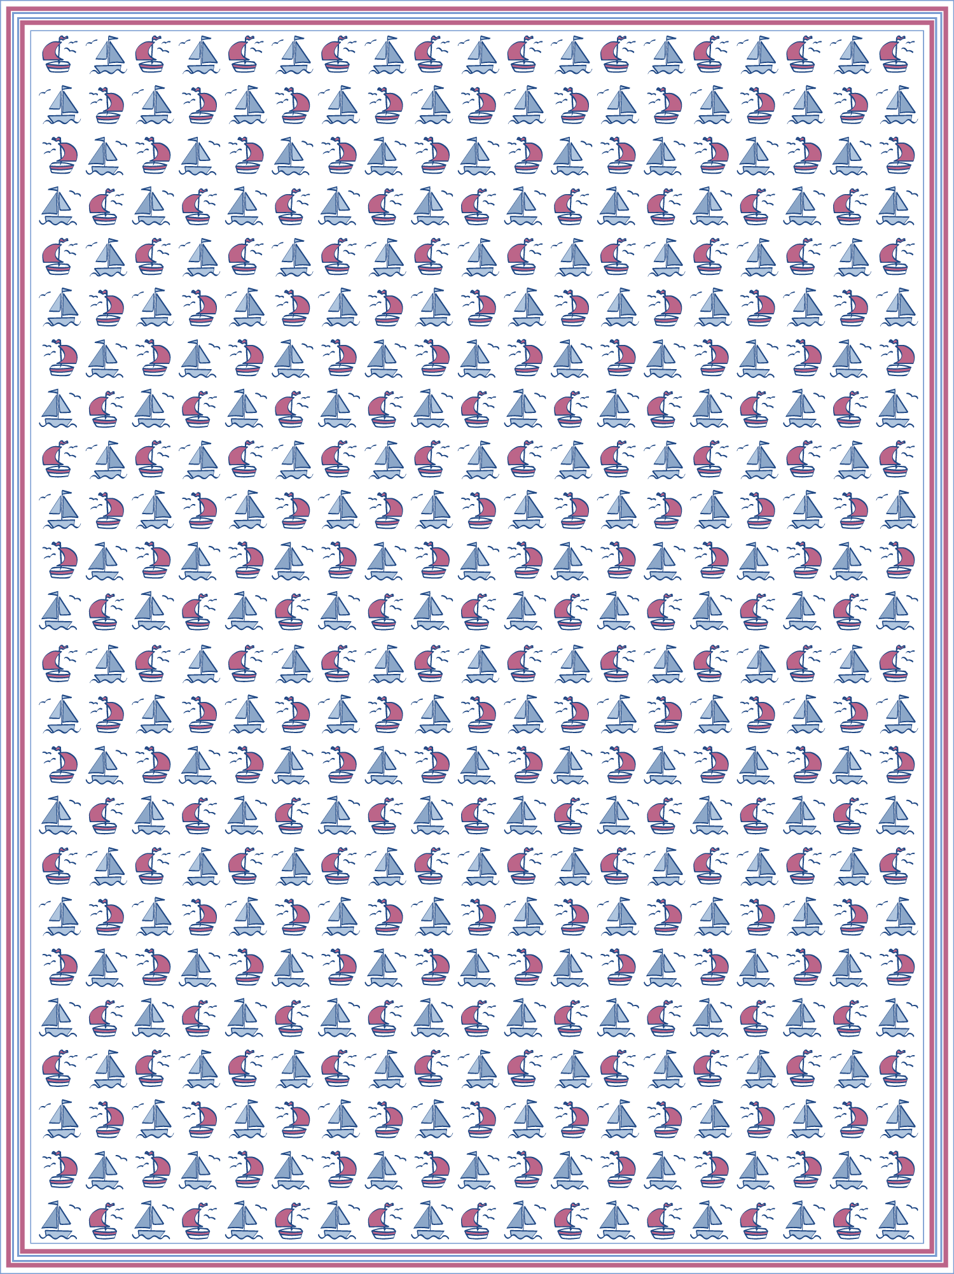



|  |  |
| --- | --- |
| Fifth Month | |
|  | |
| Date: | |
| Weight: | Length: |
| Notes: | |







|  |  |
| --- | --- |
| Sixth Month | |
|  | |
| Date: | |
| Weight: | Length: |
| Notes: | |







|  |  |
| --- | --- |
| Seventh Month | |
|  | |
| Date: | |
| Weight: | Length: |
| Notes: | |







|  |  |
| --- | --- |
| Eighth Month | |
|  | |
| Date: | |
| Weight: | Length: |
| Notes: | |







|  |  |
| --- | --- |
| Nineth Month | |
|  | |
| Date: | |
| Weight: | Length: |
| Notes: | |







|  |  |
| --- | --- |
| Tenth Month | |
|  | |
| Date: | |
| Weight: | Length: |
| Notes: | |







|  |  |
| --- | --- |
| Eleventh Month | |
|  | |
| Date: | |
| Weight: | Length: |
| Notes: | |







|  |  |
| --- | --- |
| Twelfth Month | |
|  | |
| Date: | |
| Weight: | Length: |
| Notes: | |





